EE4902 Part 2 Assignment 1

Name: Lim Jia Song John

Matriculation No.: U1321554J

# Is **Gaussian smoothing operator** a linear or non-linear filter? Explain your answer and illustrate it with images.

The Gaussian smoothing operator is a linear filter. The principle of superposition holds. i.e. if input signal is , then the output signal is for any constants and .

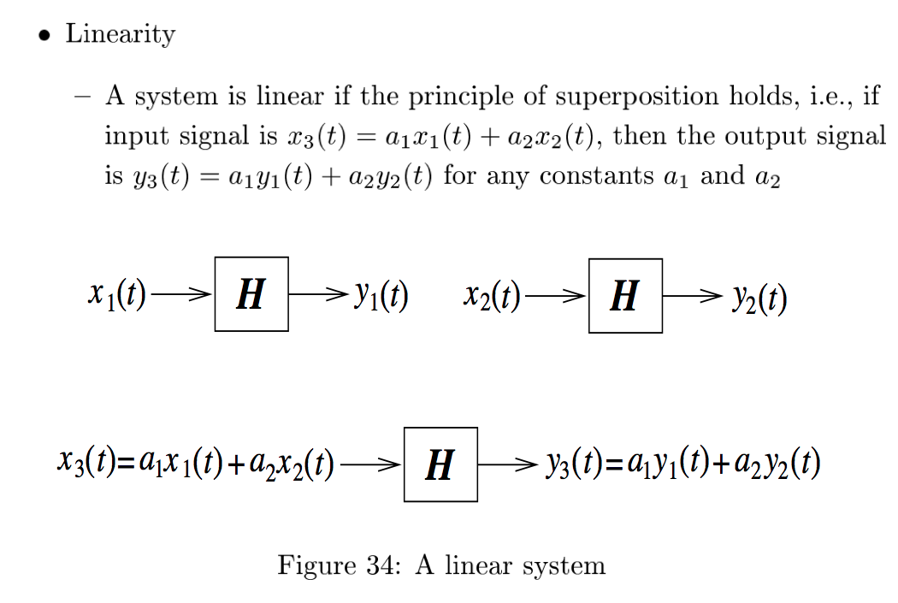

To illustrate it with images, linearly scaling the original image pixels will result in the same scaling effect on the Gaussian blurred image.

|  |  |  |
| --- | --- | --- |
| Before Blurring | After Gaussian Smoothing | After Gaussian Smoothing |
| Original Image |  |  |
| Contrast stretched image |  |  |

# Is **median filter** a linear or non-linear filter? Show that it is or is not and illustrate it with images.

A median filter is a non-linear filter. It replacing the middle pixel by the median pixel in the neighborhood and is hence unaffected by linear scaling of the image pixels. This makes it particularly suitable for impulse noise.

|  |  |  |
| --- | --- | --- |
| Original image | Impulse Noise | After Median Filter |
| Original Image |  |  |
| Contrast stretched image |  |  |
| Gaussian Blurred Image |  |  |
|  |  |  |

# Explain how the **Laplacian of Gaussian (LoG)** operator can be implemented by 1D filters?

The LoG is implemented by first convoluting the original image with a Gaussian kernel.

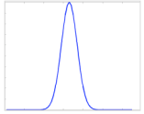

Afterwards, a Laplacian operator is performed on the Gaussian smoothed image.

The first step to doing this is to convolute the image with a 1-D filter in the x direction. This will obtain the zero crossing.

|  |  |  |  |
| --- | --- | --- | --- |
|  |  |  |  |
| Direction of Convolution  🡪 | * | |  |  |  |  |  |  | | --- | --- | --- | --- | --- | --- | | 66 | 65 | 62 | 63 | 64 | 62 | | 65 | 63 | 61 | 60 | 61 | 62 | | 55 | 60 | 58 | 57 | 56 | 55 | | 56 | 58 | 59 | 56 | 57 | 58 | | 57 | 60 | 61 | 60 | 57 | 56 | | 59 | 55 | 54 | 56 | 56 | 57 | |  |
| |  |  |  | | --- | --- | --- | | -1 | 2 | -1 | |

After the Laplacian is performed, the zero crossing is found. Performing a second derivative of a Gaussian will yield a Mexican hat operator.

|  |  |  |  |  |  |
| --- | --- | --- | --- | --- | --- |
| Direction of convolution  ↓ | |  | | --- | | -1 | | 2 | | -1 | |  |
| |  |  |  |  |  |  | | --- | --- | --- | --- | --- | --- | | 66 | 65 | 62 | 63 | 64 | 62 | | 65 | 63 | 61 | 60 | 61 | 62 | | 55 | 60 | 58 | 57 | 56 | 55 | | 56 | 58 | 59 | 56 | 57 | 58 | | 57 | 60 | 61 | 60 | 57 | 56 | | 59 | 55 | 54 | 56 | 56 | 57 | | |  |